Digital logic design lab-1
Introduction
Digital circuits makeup the cornerstone of modern computational hardware. By representing binary digits (i.e. 0,1) with voltage levels, digital circuits are able to process binary numbers electronically. Logic gates are the fundamental components within digital circuits so understanding their behavior is important. Therefore, the purpose of this experiment is to introduce you to gate behavior and logic interpretation as well as the basics of circuit wiring and troubleshooting. To do so, we will explore the function of several of the basic logic gates discussed in lecture.
2 Background
Background information necessary for the completion of this lab assignment will be presented in the next few subsections.
2.1 The 7400 Series of Logic Gates
Logic gates are constructed from transistors, which are analog switches. These transistors can be forced to operate in two modes, namely ”ON” or ”OFF.” In doing so, we can abstractly think of electronic signals within a digital circuit as being either HIGH or LOW (i.e. ’1’ or ’0’). A digital gate takes as input one or more digital signals and outputs a digital signal as a result of a Boolean operation. Figure 1 depicts the standard logic gate symbols and their associated boolean operation.

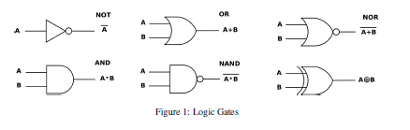
The basic gates you will study in lecture are available in a series of Integrated Circuits (ICs) commonly referred to as the “7400” series. Within this series, there are various IC package types available; however, for bread-boarding digital circuits in the laboratory, we will use the Dual-Inline Package (DIP) type as shown in Figure 2. As shown, the DIP features a black plastic package with pins on both sides, slightly resembling a flat caterpillar.
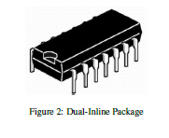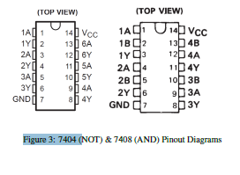
Figure 3 shows the DIP pinout diagrams for the NOT gates (left) and the AND gates (right). These pinout diagrams were taken from their respective datasheets and illustrate the function of each pin within a give
IC package. Notice that the DIP on the left (7404) contains six NOT gates arranged in a counterclockwise fashion starting at the top-left of the IC. The DIP on the right (7408) contains four AND gates arranged in a similar fashion. Also note that the notch on the DIP designates the top of the IC package.

2.2 Bread-boarding Techniques
All labs in this course require extensive bread-boarding of digital circuits. The bread-board used is depicted in Figure 4. Take a moment to examine it. Here are a few techniques which will help you wire up your circuits:
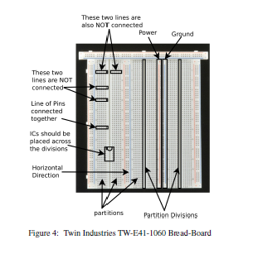

1. Horizontal lines of points on the bread-board are electrically connected together. However, lines are not connected across the partition divisions (i.e. lines in different partition are independent).
2. Vertical line are NOT electrically connected, except in the case of a power or ground line (see Figure 4).
3. Power and Ground lines shown vertically in Figure 4 are electrically connected. In lab, you will connect the 5V supply to one of the pins in the Power line. This will connect the entire column to the 5V supply. Similarly, the Ground signal needs to be connected to one pin in the Ground line.
4. All the Integrated Circuits (ICs) in the design should be placed across one of the partition divisions as shown in Figure 4. Do not place an IC in only one partition because this will short pins together causing the IC to burn up.
5. Wires connecting different IC pins should traverse horizontally or vertically only. Do not connect wires diagonally across the breadboard as this will result in a messy design making it difficult to debug.
6. Use smaller wires when connecting nearby points on the breadboard. Please use wire strippers to shorten wires if smaller sized wires are not available. This will help keep your design clean and easy to debug.
7. You may decide to always place the IC in such a way that the notch is located on the top (or bottom) as shown in Figure 4. This may help you identify pin numbers. Similarly, it might be a good idea to use color codes while wiring up your design. For example, you could assign black wires to the least significant bit, white wires to the next significant bit, green wires to the next, and red wires for the most significant bit. The color code and order of assignment is entirely your choice and for your convenience in identifying wire connections while debugging.
8. Before placing the components on the breadboard, plan the placement of your ICs such that it minimizes wiring distance on the breadboard. ICs with high connectivity should be placed near each other. For example, if LED display inputs are connected to OR gate outputs, then try to place the OR gate IC as close as possible to the LED display.

3 Lab Procedure
We will look at the behavior of logic gates in Figure 1. Each of these gates is embedded in an integrated circuit package. Consult the datasheets of each component for the pin-outs, electrical and timing characteristics of these circuits. All datasheets are available on www.alldatasheet.com.
3.1 Experiment 1
We will start by setting up the DC power supply and multi-meter for our use. Be sure both are turned off. Then check to see that the multi-meter is set to measure DC, and be sure the red lead is connected to the red multi-meter input that is marked for voltage. Finally, set the scale to the range you need to measure (usually between 0V to 5V for digital circuits). Now, set the DC power supply voltage output to zero (turn the 9 coarse adjustment counterclockwise until it stops). Connect the red lead of the power supply to the red lead of the multi-meter. Likewise, connect the black lead of the power supply to the black lead of the multi-meter.

Note: Do not connect Power (RED) and Ground (Black) together. This will cause a short.

Turn on both the multimeter and the power supply. The multimeter should read very close to zero. Turn the coarse adjustment clockwise until the multimeter reads 5V. If the multimeter display does not change significantly when you turn the coarse adjustment, turn the power supply off and recheck your connections. You may have a short. When the multimeter reads 5V, the adjustments are complete and you should turn off the power supply. You are ready to test your first gate. We will start by wiring a 74ALS04 (inverter) gate.
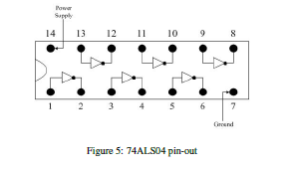
Please refer to the pin configuration given in the 74ALS04 datasheet. Insert the 74ALS04 chip onto the breadboard. Be sure you are not shorting pins together. Identify the power (VCC) and ground (GND) pins for the 74ALS04 from the pin-out of the 74ALS04 in the datasheet. Connect the VCC pin to the red lead of the power supply and connect the GND pin to the black lead of the power supply. This chip (7404) contains 6 different inverter gates. Each inverter gate has an input pin and a corresponding output pin. Choose one of the gates and connect the red lead of the multimeter to the gate output. The black lead of the multimeter should always be connected to the black lead of the power supply (at the GND pin). Then connect a wire from either the VCC pin to the input (for a logic High input) or from the GND to the input (for a logic Low input). Do not connect both at the same time, as this will cause a short. Turn on the power supply and
observe the gate output. Assume A is the input to the inverter (either High or Low) and that Y is the output.
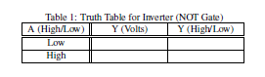

Note: First fill in the second column of the table using the readings from the multimeter. Then determine the answers to the last column based upon these readings. If the output is high (H), the multimeter will read approximately 3.9V - 4.2V; when it is low (L), the multimeter will read about 91.9 mV. If you read a voltage between these values, you have likely wired your circuit incorrectly. Please demonstrate your progress so far to the Instructor.
Repeat the experiment for AND and OR gates as well. The datasheet of AND gate (7408) and OR gate (7432)are given below:
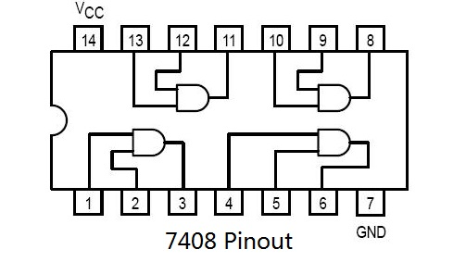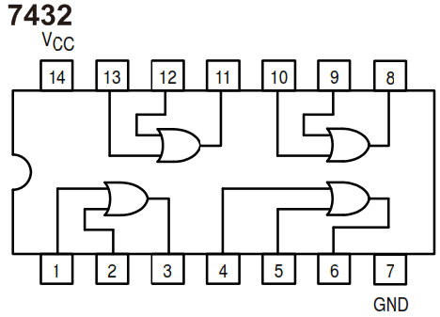

Fill in the following table according to your lab inputs and outputs.

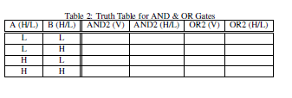
You can watch the following video for further illustration.
https://www.youtube.com/watch?v=cdMJvFT-Afc

